**COMP 3005 Project V2 Report** Jonah Habtom

**Video**

Here is the link to the video demo for my project: <https://youtu.be/Mc1ApSgrZSE>

**GitHub Repository**

Here is the link to my public GitHub repository for this project: [jonahhabtom/Health-and-Fitness-Club-Management-System](https://github.com/jonahhabtom/Health-and-Fitness-Club-Management-System)

**Conceptual Design**

Below is the ER diagram for the health and fitness club (the diagram can also be viewed here [Health-and-Fitness-Club-Management-System/Diagrams/ER Diagram.png at main · jonahhabtom/Health-and-Fitness-Club-Management-System](https://github.com/jonahhabtom/Health-and-Fitness-Club-Management-System/blob/main/Diagrams/ER%20Diagram.png)):

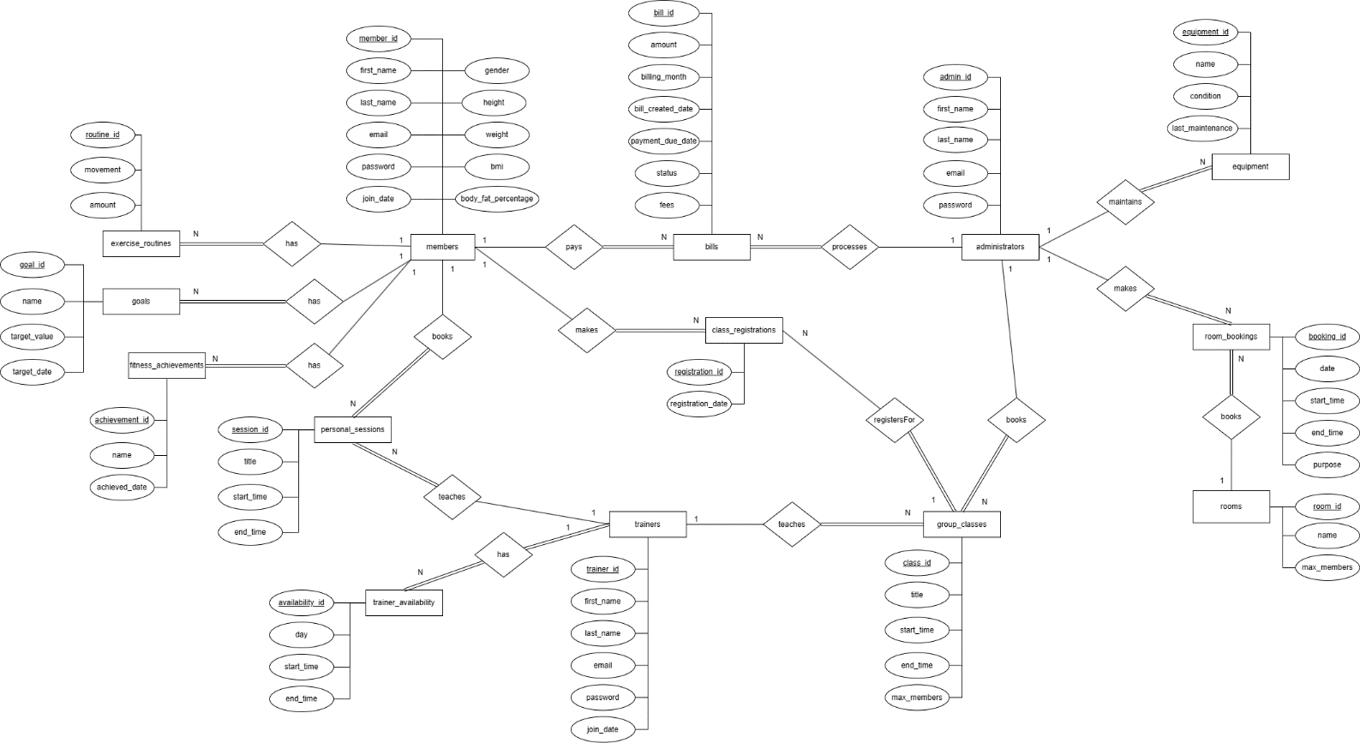

The database is composed of 14 tables to cover all the functionality in the requirements. The members table holds members of the club, their personal information and their health statistics. The trainers table holds the trainers of the club and their login information. The administrators table holds the admins for the fitness club system and their login information. The trainer_availability table holds availability for a trainer, specifically the day of the week and start and end times. The personal_sessions table is for personal 1 on 1 training sessions between a trainer and a member and the group_classes hold the group fitness classes, with the class_registrations table holding records representing registrations for those group fitness classes. The equipment table holds the equipment in the gym and their maintenance information. The rooms table holds the available rooms in the gym and the room_bookings table holds the bookings and booking information for the rooms. The fitness_achievements table holds fitness achievements and the date they were achieved on for members. The goals table holds goals for members of the fitness club. The exercise_routines table holds exercise routines for members of the club. Finally, the bills table holds bills for a specific month for a member.

Assumptions made regarding cardinalities and participation types:

* One member can have 0 to N exercise routines, goals, fitness achievements, scheduled personal sessions, class registrations, and bills to pay
* A trainer can teach multiple personal training sessions and group classes but a personal training session and group class can only have one trainer
* One trainer can have multiple records in trainer_availability. For example, can be available Monday, Wednesday, and Thursday
* A group class can have multiple registrations
* An administrator can process multiple bills, create multiple group classes, perform maintenance on multiple pieces of equipment, and make multiple room bookings
* A room can have multiple room bookings

**Reduction to Relation Schemas**

Below is the relational schema diagram which was reduced from the ER diagram above (the diagram can also be viewed here [Health-and-Fitness-Club-Management-System/Diagrams/Relational Schema Diagram.png at main · jonahhabtom/Health-and-Fitness-Club-Management-System](https://github.com/jonahhabtom/Health-and-Fitness-Club-Management-System/blob/main/Diagrams/Relational%20Schema%20Diagram.png)):

**DDL File**

Here is the link to the DDL SQL file: [Health-and-Fitness-Club-Management-System/SQL/ddl.sql at main · jonahhabtom/Health-and-Fitness-Club-Management-System](https://github.com/jonahhabtom/Health-and-Fitness-Club-Management-System/blob/main/SQL/ddl.sql)

**DML File**

Here is the link to the DML SQL file: [Health-and-Fitness-Club-Management-System/SQL/dml.sql at main · jonahhabtom/Health-and-Fitness-Club-Management-System](https://github.com/jonahhabtom/Health-and-Fitness-Club-Management-System/blob/main/SQL/dml.sql)

**Implementation**

My Health and Fitness Club application is implemented in Python and uses the Psycopg adapter for connecting and interacting with the PostgreSQL database.

The application assumes the form of a command-line interface. The starting interface provides options for logging in as a member, trainer, or administrator or registering a new member. Depending on what role the user logs in as, they will be presented with the menu interface containing the functionality available for that role.

main.py contains the code for the main menu and connecting to the database. member.py contains all the functions for members of the fitness club. trainer.py contains all of the functions for tasks trainers of the club can perform. admin.py contains all of the functions related to the functionality of an administrator for the fitness club.